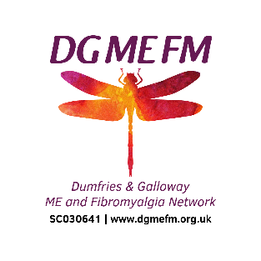
DGMEFM Network
Learning Event
12th May 2022
Resources

Learning Event Session | https://youtu.be/bulciv6d9K8
DGMEFM Website | https://dgmefm.org.uk/
DGMEFM Facebook Page (public) | https://www.facebook.com/dgmefmnetwork
DGMEFM Facebook Group – support (private group) | https://www.facebook.com/groups/dgmefm
DGMEFM Facebook Group – social (private group) | https://www.facebook.com/groups/DGMEFMsocial
DGMEFM Facebook Group – arts and crafts (private group) | https://www.facebook.com/groups/getcraftywithdgmefm
Implementation Statement from The National Institute for Health and Care Excellence | https://meassociation.org.uk/2022/05/nice-outlines-steps-needed-to-put-me-cfs-guideline-into-practice/
NICE Guidelines and NICE Guidelines summary | https://meassociation.org.uk/about-what-is-mecfs/nice-clinical-guideline/
Care Opinion | https://www.careopinion.org.uk/
Patient Experience | https://www.nhsdg.co.uk/how-did-we-do/
Chronic Pain Video | https://www.tiktok.com/@trugrace.mua/video/7075799870388325637?is_from_webapp=1&sender_device=pc&web_id=7080816439271736838&fbclid=IwAR2C_kaeF04Kx25nQJEe-P_g8NHfYvqut-sUJRtlRsvxsEn-xQEWK-Ahwzw
ME Animation | https://voicesfromtheshadowsfilm.co.uk/2018/animation-for-severe-me-day/

